KeyMinder
Instruction For 4 Dial Combination Lock
Your KeyMinder® Box is factory preset to “ 0-0-0-0 ”
Record your new secret number here “ _ _ _ _ ”
To Open: Rotate all 4 dials to the pre-set combination, grasp the sides on the top section of the box and pull lid towards you.
Resetting Combination Instructions: Please read all instruction thoroughly before resetting!
Fig. 1
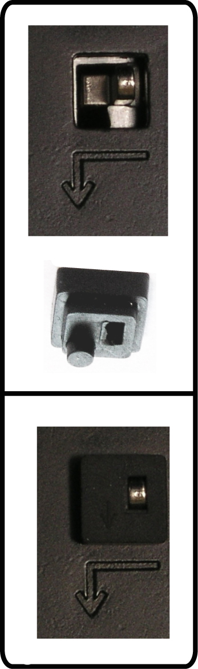
- Open the KeyMinder® using the secret number (the factory preset is “0-0-0-0”)
- Remove the small black cap which is located around the silver pin on the inside of the box. see fig. 1
- Slide the reset pin to the left and down as per arrow (Lid should be opened toward you with the hinge at the bottom)
- Rotate the 4 dials on the front to your new secret combination. Ensure the numbers are positioned centrally and have clicked into position
Memorise and record the new combination for future reference and keep safe
- Return the reset pin, inside the box, to the original position – (up and to the right, in the opposite direction of arrow)
- Re-insert the black cap around the silver pin. (The cap will be flush with pin when fitted correctly). see fig. 2
- Close the lid.
Fig. 2
To lock the box the combination must be scrambled by rotating the 4 dials
- Check the operation of the lock box using the new combination
User Instructions:
Insert keys (objects) into storage area of box, close the storage lid and scramble the dials to lock.
Fitting Instructions:
The box should be mounted on to a solid wall using all 4 corner holes on the back plate. Screws should be tight without distorting the back plate. The flexible gasket on the back should be used for all installations. Wall plugs should be used for masonry and brick walls.
Choosing The Right Position To Fit: KeyMinder® should be mounted in a discreet location for maximum protection and in an area with sufficient light for authorised users to see the dials. Box can be used inside and outside.
Maintenance:
It is recommended the dials are rotated weekly to keep them moving freely.
KeyMinder
Instruction For 4 Dial Combination Lock
Your KeyMinder® Box is factory preset to “ 0-0-0-0 ”
Record your new secret number here “ _ _ _ _ ”
To Open: Rotate all 4 dials to the pre-set combination, grasp the sides on the top section of the box and pull lid towards you.
Resetting Combination Instructions: Please read all instruction thoroughly before resetting!
Fig. 1
- Open the KeyMinder® using the secret number (the factory preset is “0-0-0-0”)
- Remove the small black cap which is located around the silver pin on the inside of the box. see fig. 1
- Slide the reset pin to the left and down as per arrow (Lid should be opened toward you with the hinge at the bottom)
- Rotate the 4 dials on the front to your new secret combination. Ensure the numbers are positioned centrally and have clicked into position
Memorise and record the new combination for future reference and keep safe
- Return the reset pin, inside the box, to the original position – (up and to the right, in the opposite direction of arrow)
- Re-insert the black cap around the silver pin. (The cap will be flush with pin when fitted correctly). see fig. 2
- Close the lid.
Fig. 2
To lock the box the combination must be scrambled by rotating the 4 dials
- Check the operation of the lock box using the new combination
User Instructions:
Insert keys (objects) into storage area of box, close the storage lid and scramble the dials to lock.
Fitting Instructions:
The box should be mounted on to a solid wall using all 4 corner holes on the back plate. Screws should be tight without distorting the back plate. The flexible gasket on the back should be used for all installations. Wall plugs should be used for masonry and brick walls.
Choosing The Right Position To Fit: KeyMinder® should be mounted in a discreet location for maximum protection and in an area with sufficient light for authorised users to see the dials. Box can be used inside and outside.
Maintenance:
It is recommended the dials are rotated weekly to keep them moving freely.

